* SQL is a language used to interact with relational database management systems
* Relational database management system: Software application that can be used to create and manage different databases

What is a database? (DB)

* A collection of related information
* Databases can be stored in different ways
* 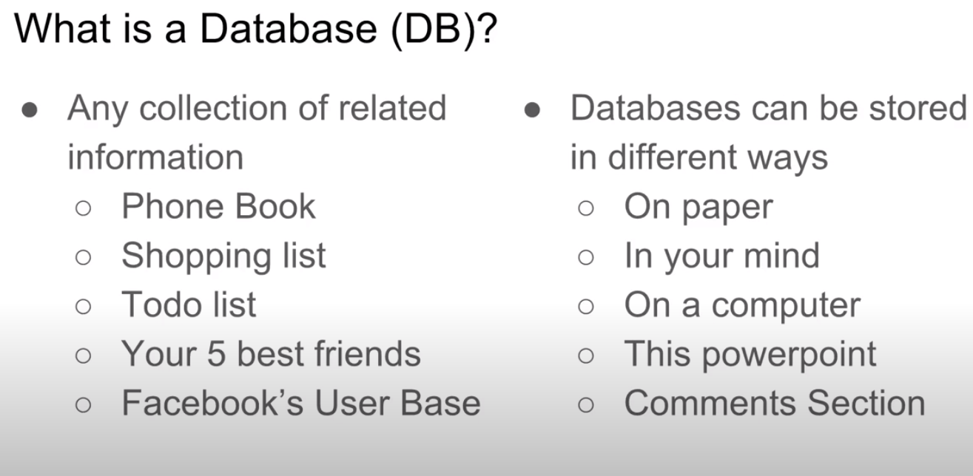
* Experience: Active Directory
  + Store users information
    - End-user account
* Computers + Databases = <3
  + Point: storing a collection of related information on a computer is extremely important (databases on computer)
    - Computers are great at keeping track of large amounts of information
    - 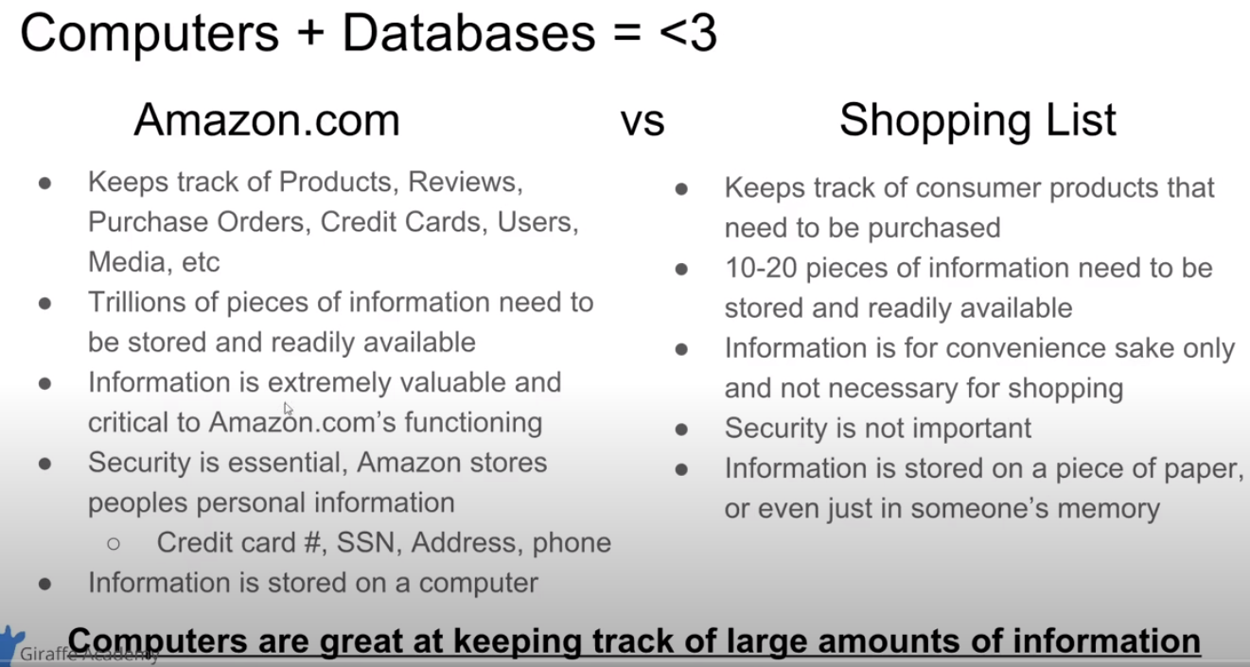

How can we create databases on a computer?

* Database Management Systems (DBMS): a special software program that helps users create and maintain a database on a computer
  + This isn’t the actual database
* Helps store trillions of pieces of information
* 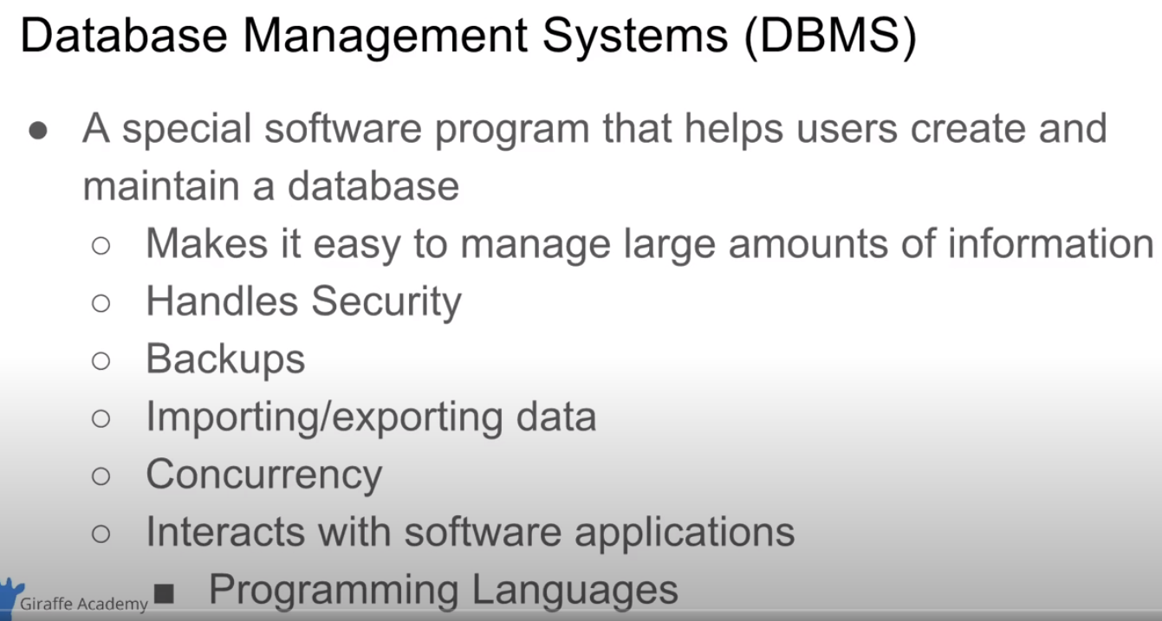
* 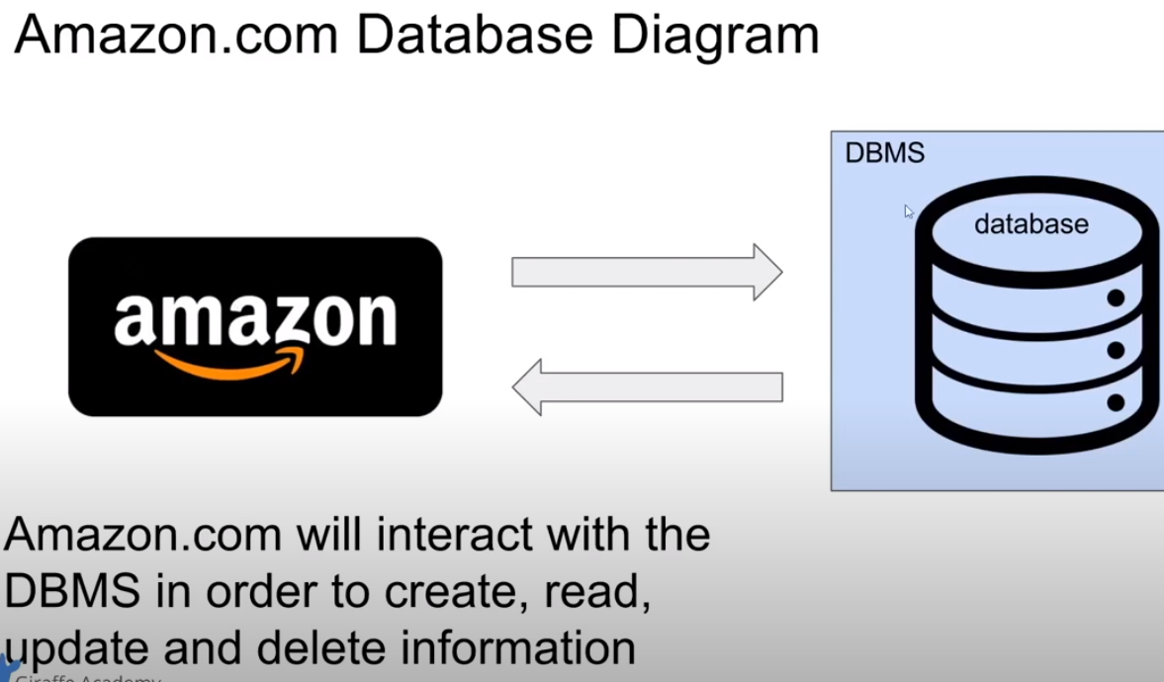
  + Amazon communicates w/ DBMS

CRUD

* C.R.U.D.; create, read, update, delete
* 4 main operations related to a database
* 4 main operations we want the database management system (DBMS) to perform
* 
* Two main types of Databases
  + 2 main types in computing:
    - 1. Relational Databases (a.k.a. SQL)
      * Most popular type
      * Organizes data into one or more tables
        + Each table has rows & columns
        + A unique key identifies a row
      * Alot like an Excel spreadsheet
    - 2. Non-Relational (a.k.a. noSQL / not just SQL)
      * Anything but a traditional table
      * Very general
      * JSON = java script object notn
  + 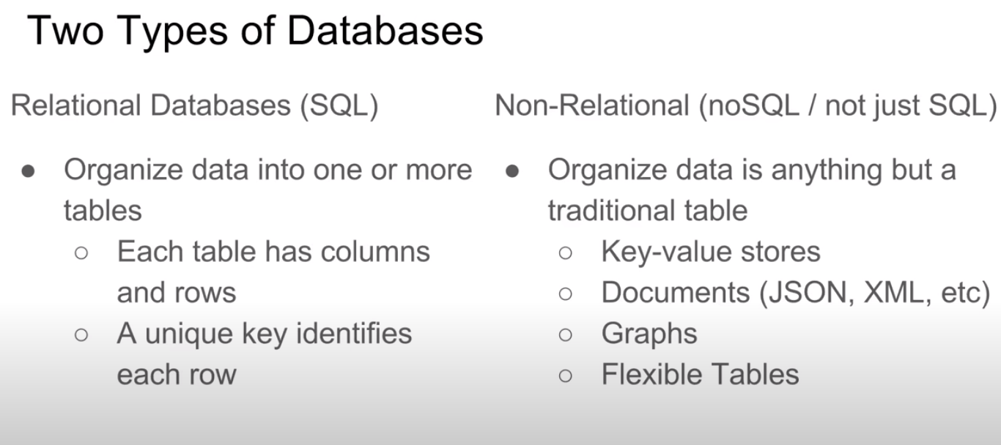
  + 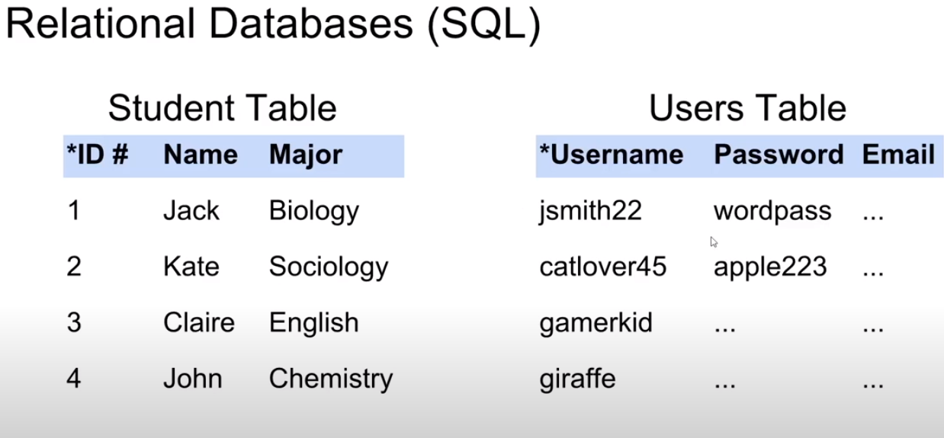
    - Id, username uniquely identifies row for tht table
  + Relational Databases (SQL)

Relational Database Management Systems (RDBMS)

* Help users create and maintain a relational database
  + mySQL, Oracle, postgreSQL, mariaDB, etc.

Structured Query Language (SQL) (RDBS uses this)

* Standardized language (means it’s pretty much used on every RDBMS) for interacting with RDBMS
* Used to perform C.R.U.D. operations, as well as other admin tasks (user management, security, backup, etc.)
* Used to define tables & structures
* SQL code used on one RDBMS is not always portable to another without modification

Non-Relational Databases (Anything that is NOT relational; anything but a table) (noSQL/ not just SQL)

* 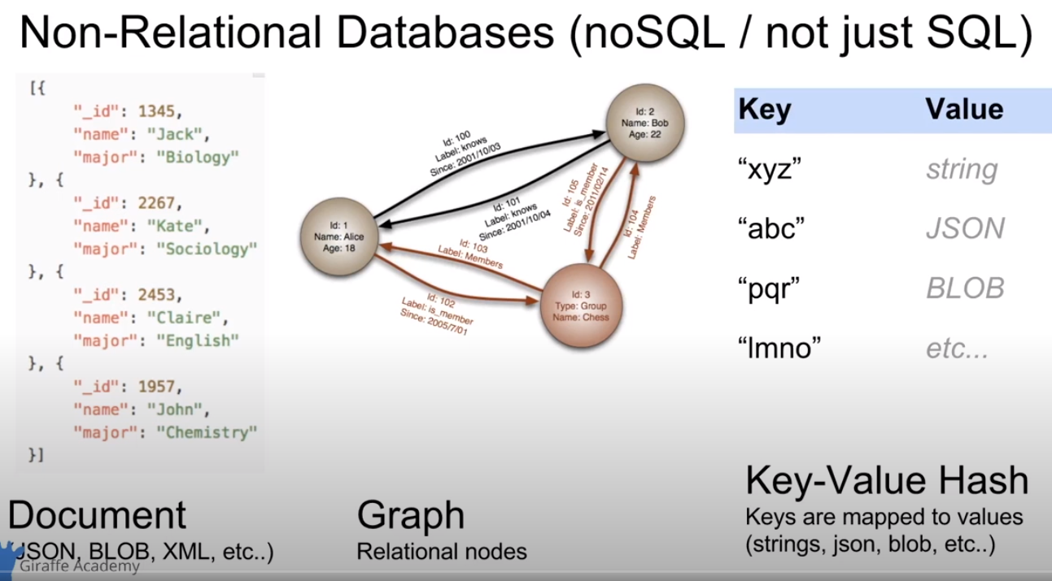
* Examples of non-relational data bases
* Json = java script object notation
* Graphs
* Key-value hash
* Non-relational Database Management Systems (NRDBMS)
  + Help users create and maintain a non-relational database
* Implementation Specific
  + Any non-relational database falls into this category, so there’s no set language standard
  + Most NRDBMS will implement their own language for performing C.R.U.D. and admin operations on the database
  + 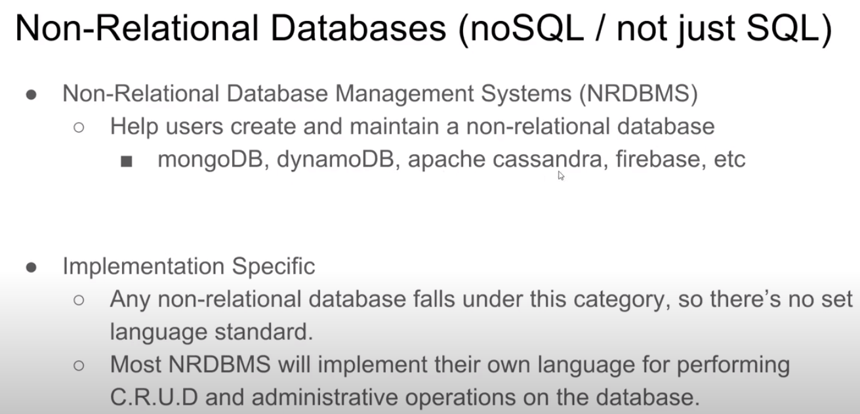

Core Concepts w/in Databases:

Database Queries

* Queries are requests made to the DBMS for specific information
* As the database structure become more and more complex, it becomes more difficult to get the specific pieces of information we want
* A google search is query
* Will usually write query in SQL or another language of which the DBMS uses

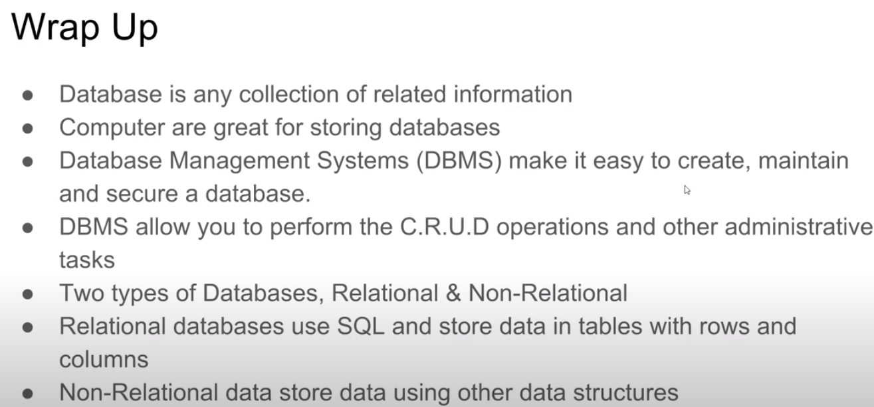

* Query -> DBMS -> DB -> got info

Tables and Keys

* Tables in RDB have cols & rows

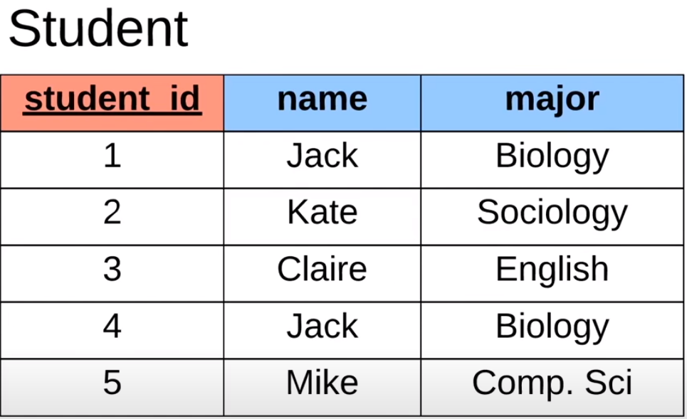

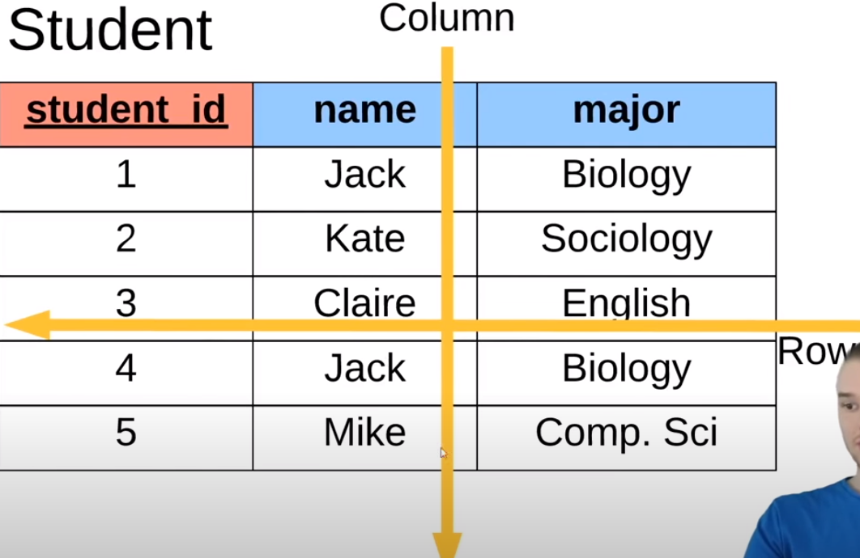

* Each column defines a single attribute
* Each row represents a single student (shows multiple attributes)
* ALWAYS want one column to be / act as the PRIMARY KEY
* Primary key: attribute that uniquely defines a row within a database;

attribute that uniquely defines the student (in this case it is the id column)

* 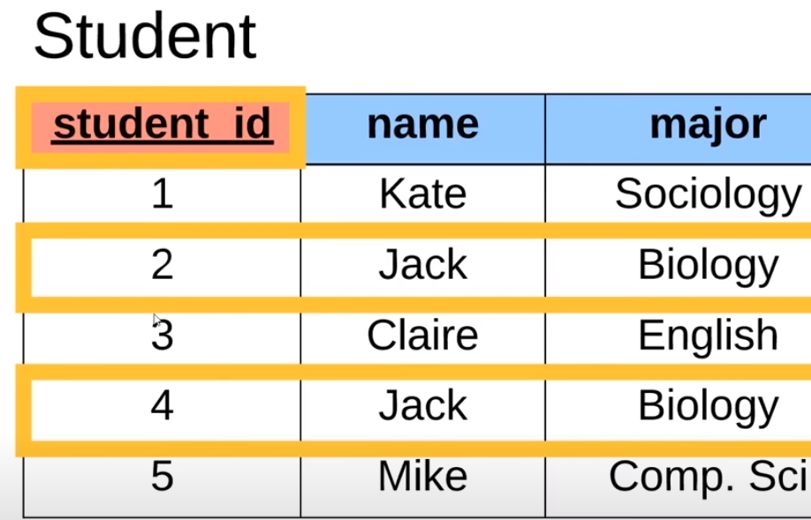
* Generally, within a database, we always want to define a primary key
* 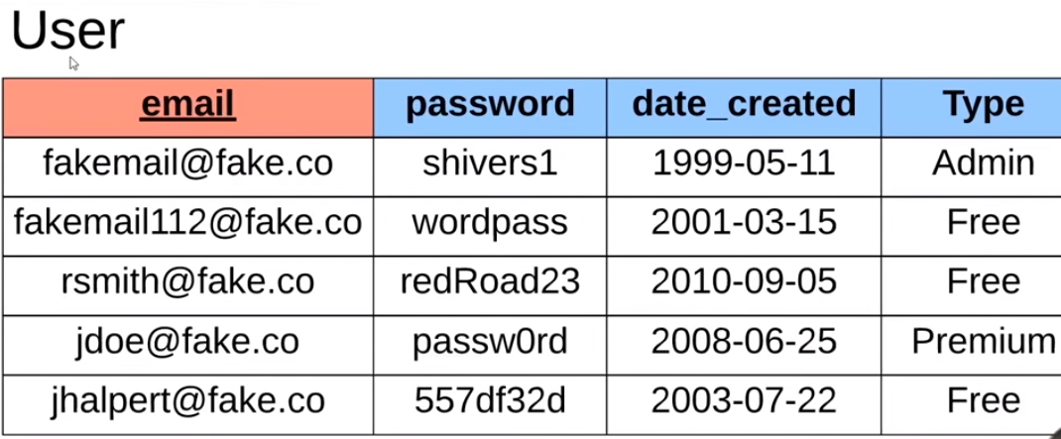
* Our primary key could really be anything; i.e. number, letters, words, etc.
  + In the case above, the primary key is ‘email’
    - Unique to every entry of the table
* 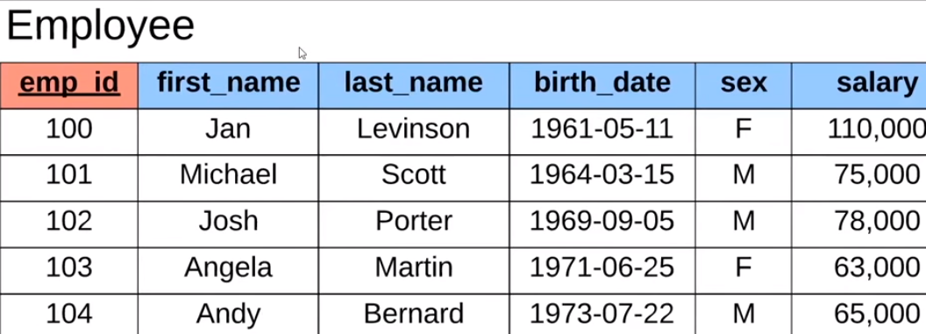
* Emp-id = **surrogate key**; means it’s an entry that doesn’t really map to anything in the real world
  + Random #
  + **Natural key** = has a mapping in the real world & not just the database
  + 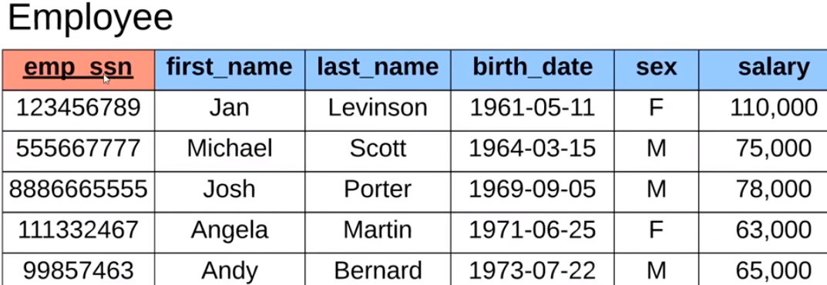
  + Primary key in this case: ssn; it is also the natural key
  + natural key & surrogate key
  + **Foreign key** = attribute you can store on a database table that will link us to another database table
  + 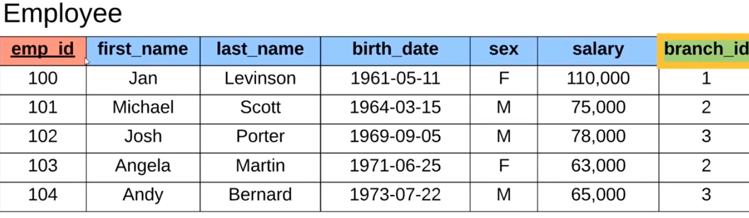
    - Branch_id - is a foreign key; can store the information of which branch the employee belongs to; in this case the foreign key is a primary key of another table
    - (the branch table)
    - 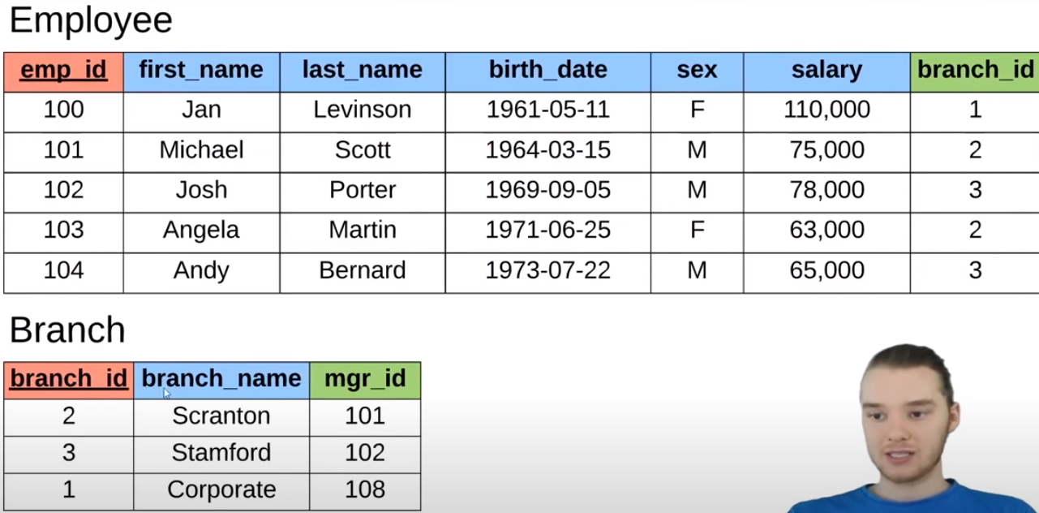
      * branch_id = primary key of the ‘Branch’ table
      * w/in ‘Employee’ it is basically mapping to the primary key of ‘Branch’
      * Foreign key defines a relationship b/w tables; primary key of another table
      * Ex. Andy is defined to be part of the Stanford branch
      * Mgr_id is the emp_id within ‘Employee’; another foreign key; connecting ‘Branch’ to ‘Employee’
      * So, for ex. Manager / employee w/ mgr_id 101 is Michael Scott; manager of Scranton branch
    - NOTE: A table can have multiple foreign keys
    - 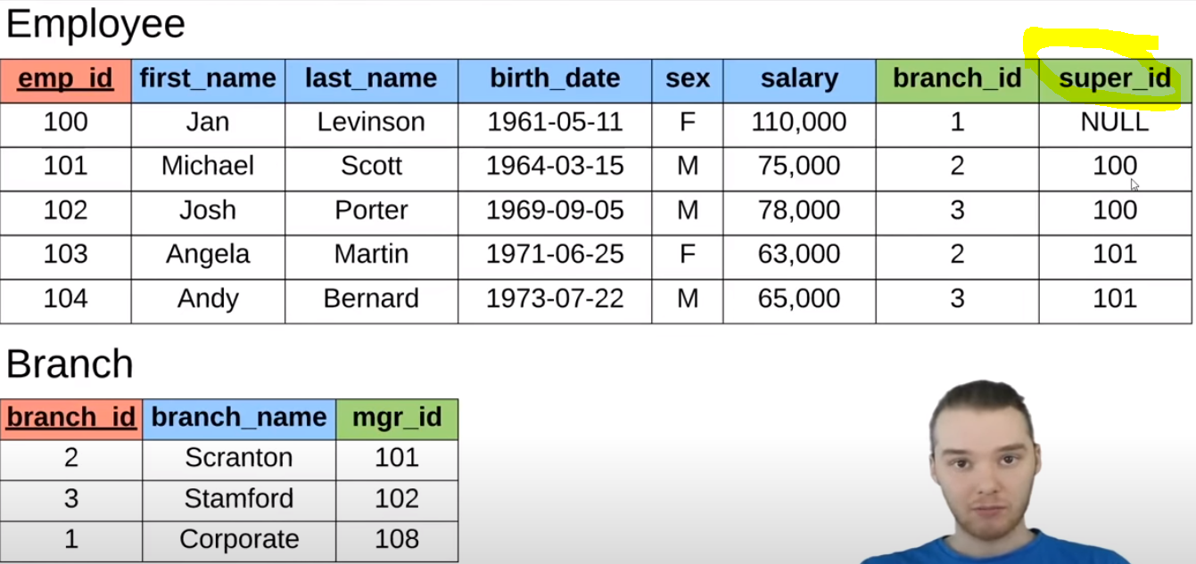
    - super_id defines who is the supervisor of a particular employee
    - Ex. Michael Scotts supervisor is Jen Levinson
    - 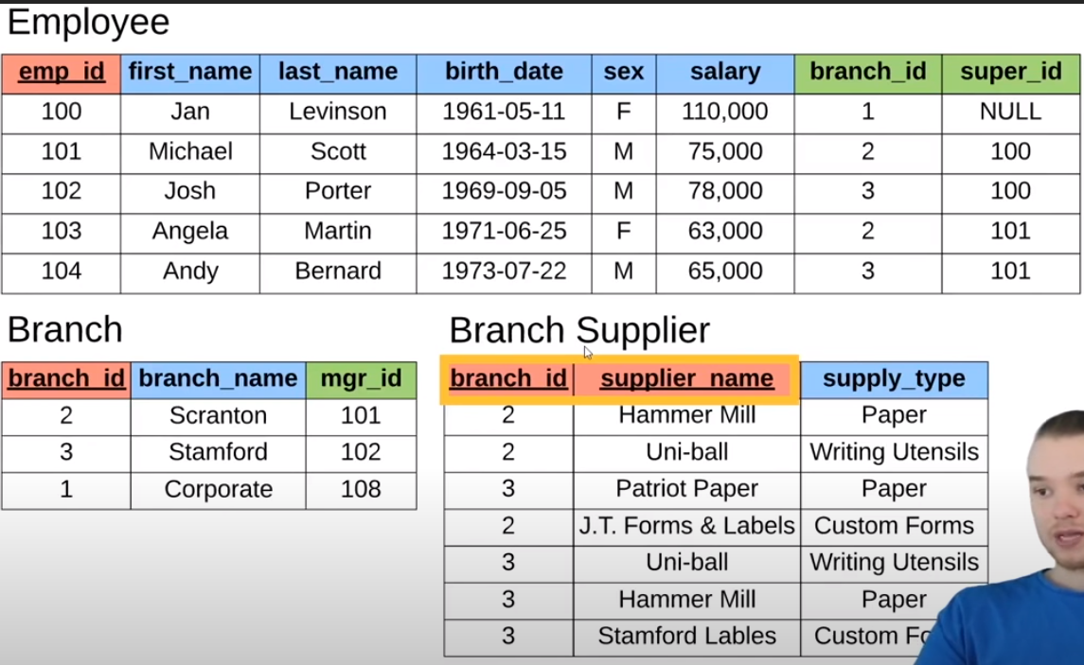
    - Notice primary key of ‘Branch Supplier’ consists of 2 columns
      * This is called a **composite key**
      * Composite key: key made up of 2 attributes
      * Ex. Hammer mill supplies Scranton w/ Paper
      * So the ‘Branch Supplier’ shows/ determines What supplier & what they supply them w/
      * Composite key is NEEDED b/c branch_id alone cannot uniquely identify each row and supplier_name cannot uniquely identify each row; only TOGETHER they can uniquely determine each row
      * Notice: Uniball supplies to branch 2 and 3 (branch_id is repeated)
      * supplier_name is repeated - Ex. hammer mill & uni-ball
      * Only together (branch_id & supplier_name) can they uniquely identify the table
      * ‘Employee’ and ‘Branch’ both have ONE column as a primary key
      * ‘Branch Supplier’ has TWO columns as a primary key
      * 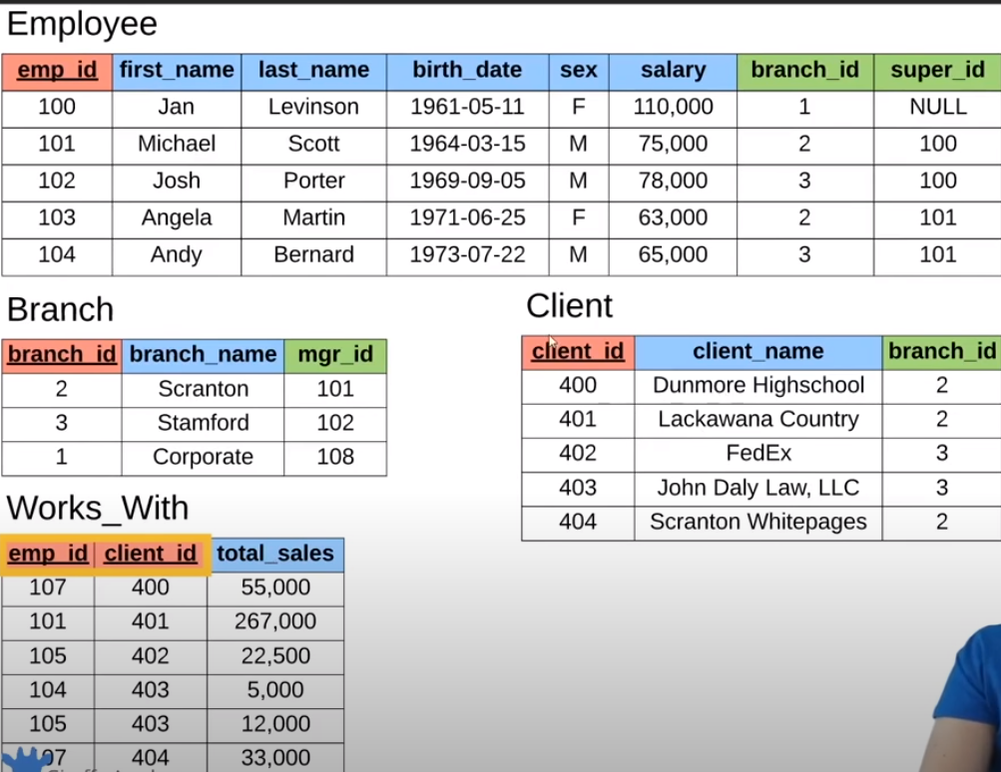
      * Ex. Client Dunmore Highschool will buy from Scranton branch
      * ‘Works_With’ defines the relationship between employees & clients; namely how much sales/ paper an employee sells to a specific client
      * Ex. ‘101’ Michael Scott has sold total of $267 000 in sales to ‘400’ Lackawana County
      * ‘Works_With’ has composite key: emp_id & client_id; this is a special type of composite key b/c BOTH columns are foreign keys; these two (composite key) defines how much product is bought
* Basically showed tables & keys & different relations that can be established within a relational database

SQL Basics

Structured Query Language (SQL)

* SQL is a **language** used for interacting with Relational Database Management Systems (RDBMS); RDBMS: it’s a piece of software/ software application that can be used to maintain a relational database
* Used to communicate with the DBMS
  + You can use SQL to get the RDBMS to do things for you
    - Create, retrieve, update & delete data
    - Create & manage databases
    - Design & create database tables
    - Perform admin. tasks (security, user management, import/export, etc.)
* SQL implementations vary between systems
  + Not all RDBMS’ follow the SQL standard to a ‘T’
  + The concepts are the same but the implementation may vary
* SQL is actually a hybrid language, it’s basically 4 types of languages in one
  + Data Query Language (DQL)
    - Used to query the database for information
    - Get information that is already store there
  + Data Definition Language (DDL)
    - Used for defining database schemas
    - Schema: overall layout of the database
  + Data Control Language (DCL)
    - Used for controlling access to the data in the database
    - User & permissions management
    - Ex. user can update & delete info
  + Data Manipulation Language (DML)
    - Used for inserting, updating and deleting data from the database
    - CRUD

Queries

* Query: Set of instructions given to the RDBMS (written in SQL) that tell the RDBMS what information you want it to retrieve for you
  + TONS of data in a DB
  + Often hidden in a complex schema
  + GOAL: to only get the data you need
    - SELECT employee.name, employee.age
    - FROM employee
    - WHERE employee.salary > 30000:
* 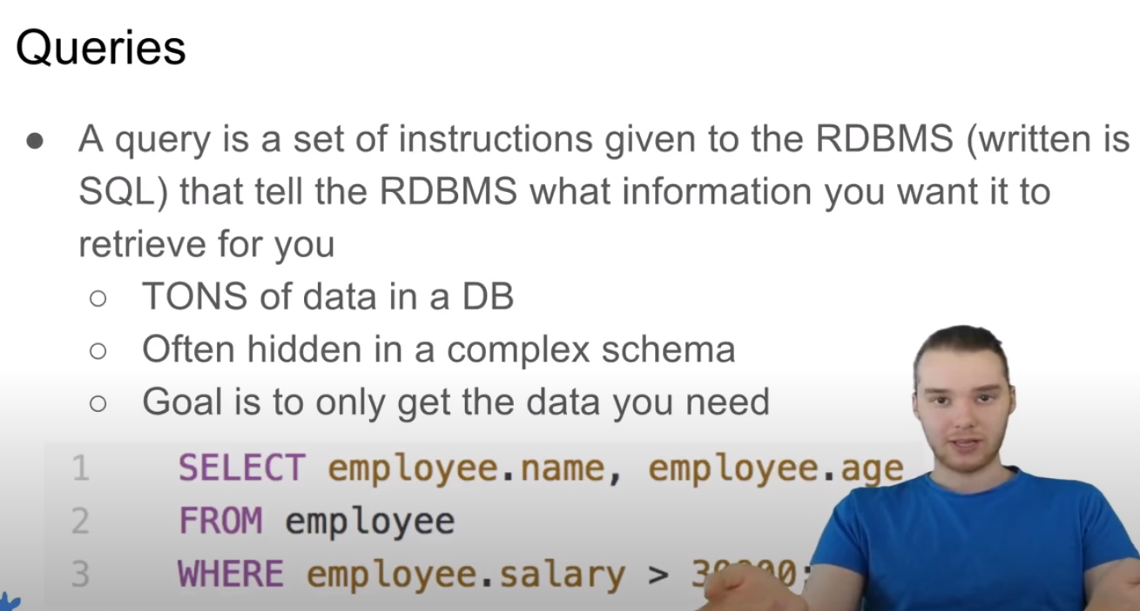

MySQL Windows Installation

* MySQL = RDBMS; it is a software app used to maintain, create, CRUD in databases
* PopSQL - texteditor that hooks up w/ mysql database
* 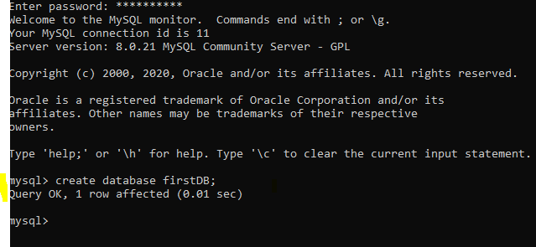
* Will also use popSQL
  + popSQL is kinda like googldocs, but for queries

Creating Tables

* want : start defining the database schema
* ‘Create table’ then add other stuff we want
* 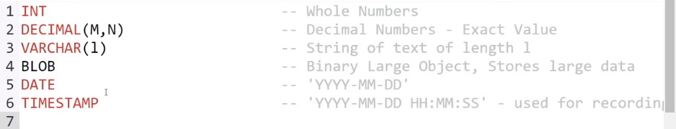
* Above makes up the core SQL data types; all can be used in the MySQL database
* DECIMAL(M,N); M: total number of digits you want to store for this number; N: number of digits you want to store after the decimal point
  + Ex. DECIMAL(10,4) -> means we want to store a decimal number with 10 total digits and 4 digits after the decimal point
* VARCHAR(l): Variable Character; this is a way of which/ how we can store a string of text
  + Ex. VARCHAR(100) -> means will store a string of text with 100 characters
* BLOB: structure that can store large amts of binary data
  + Ex. can store images & files inside a BLOB, allowing it to be stored inside the DB
* TIMESTAMP similar to DATE; but more specific, i.e. recording time
* 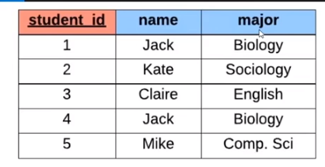
* Want to store this info above
* Any command you write in SQL is ALWAYS going to end in a semi colon (;)
* student_id is the primary key; it uniquely defines the rows
* 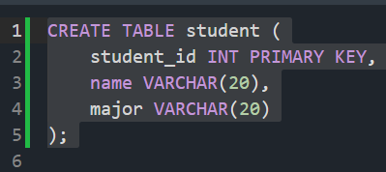
* OR PRIMARY KEY (student_id)
* 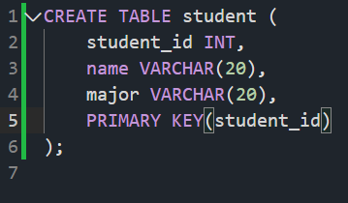
* Both are equivalent
* 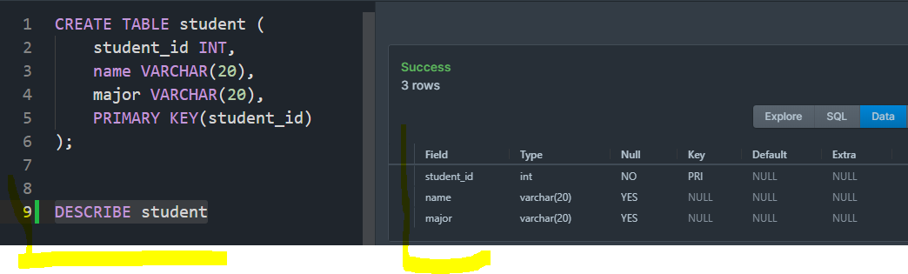
* Delete table: DROP TABLE student
* 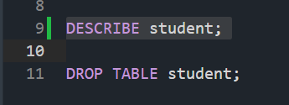
* 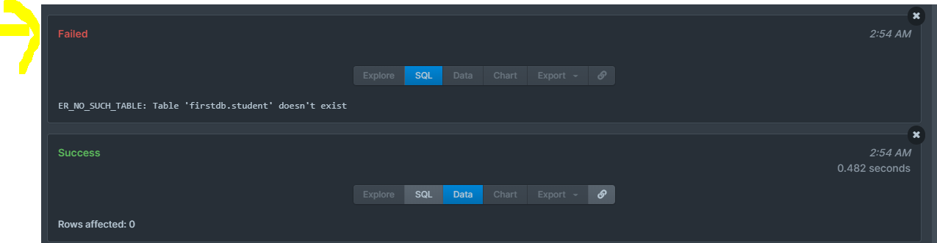
* Now it doesn’t exist b/c we deleted the table
* Adding another column: ALTER TABLE student ADD gpa DECIMAL(3,2);
* 
* 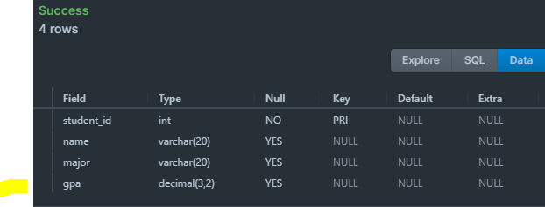
* Delete a column: ALTER TABLE student DROP COLUMN gpa;
* 
* 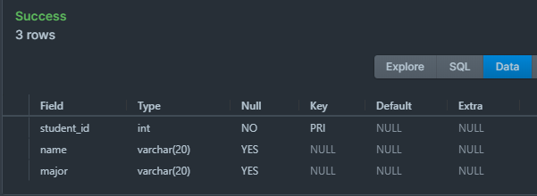

Inserting Data

Into Database Tables

* How to insert values
* INSERT INTO student VALUES();
* INSERT INTO student VALUES(1, ‘Jack’, ‘Biology’); ** NOTE: the order when created the table
* 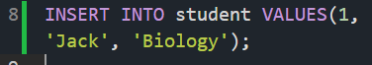
* 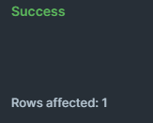
* Affected 1 row in the student table
* SELECT * FROM student -> selects all the information from the student table
* 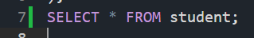
* 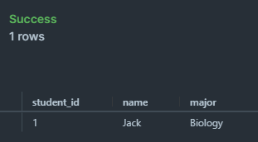
* So, so far we have 1 student in the table
* Add another: INSERT INTO student VALUES (2, ‘Kate’, ‘Sociology’);
* 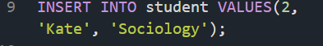
* 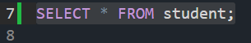
* 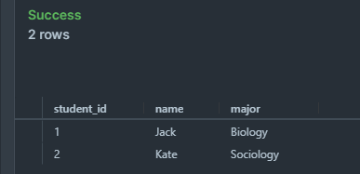
* What if we had a case where a student didn’t have a major/ we didn’t know what their major was; so we couldn’t insert it into the database?
  + INSERT INTO student(student_id, name) VALUES(3, ‘Claire’);

C

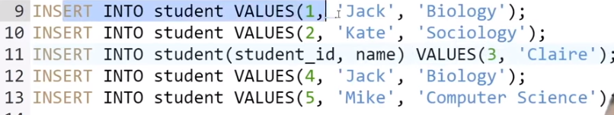

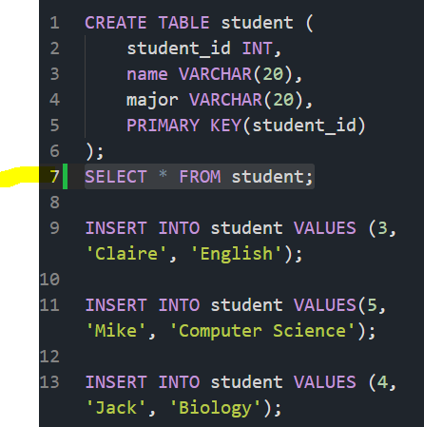

* Info in DB
* 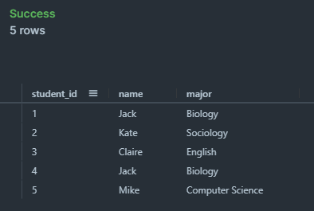
* Now, want to create the student table that makes it easier for us to insert stuff
  + NOT NULL
  + UNIQUE
  + Both are great ways to control the data stored on the table
  + Note: PRIMARY KEY is both NOT NULL & UNIQUE
  + NOT NULL & UNIQUE can also be referred to as constraints
* 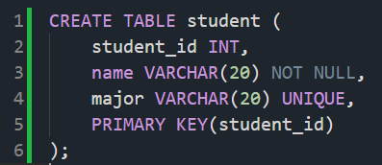
* Notice the yelling that should be happening below due to the restrictions
* 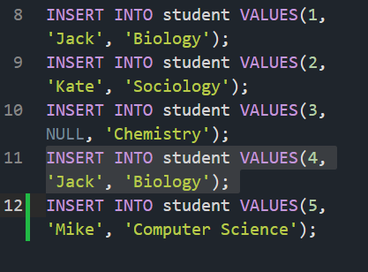
* Entering a default value
* … major VARCHAR(20) DEFAULT ‘undecided’,
* 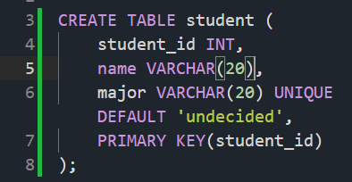
* 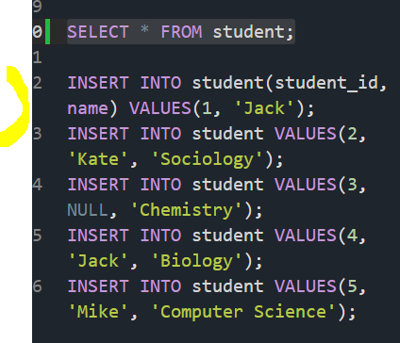
* Since Jack has no major, it will automatically populate for us as ‘undecided’
* DEFAULT acts as another constraint
* Cpart3 another constraint
* Have db do primary key for you
* ...student_id INT AUTO_INCREMENT,
* Notice: we’ll be only inserting the name and major
* 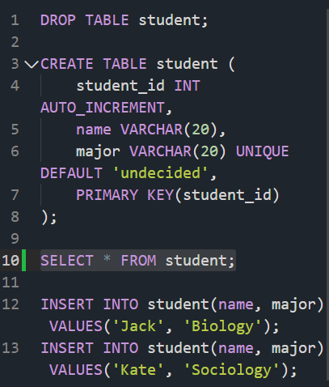
* Notice automatic generation of student_id
* AUTO_INCREMENT is another constraint

Update & Delete

* UPDATE student
* SET major = ‘Bio’
* WHERE major = ‘Biology’;
* Other comparison ops:
* =: equals
* <>: not equals
* >: greater than
* <: less than
* >=: greater than or equal
* <=: less than or equal
* 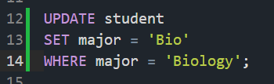
* 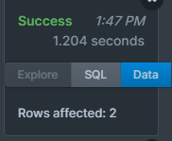-> means affected 2 rows w/in the database
* Makes sense because 2 rows have ‘Biology’ as the major
* 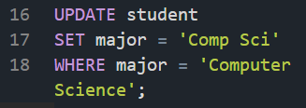
* 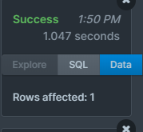
* 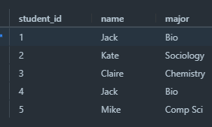
* Can also update specific things; i.e. w/ different conditions; for example consider changing major of student that has student_id = 4
* 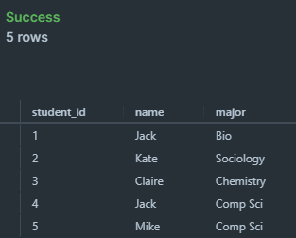
* Notice: Jack is now a CompSci major (originally Bio major)
* OR statement
* UPDATE student
* SET major = ‘Biochemistry’
* WHERE major = ‘Bio’ OR major = ‘Chemistry’;
  + Basically combining the 2 majors together
* 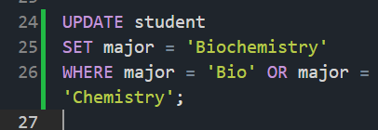
* 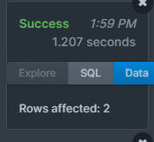
* 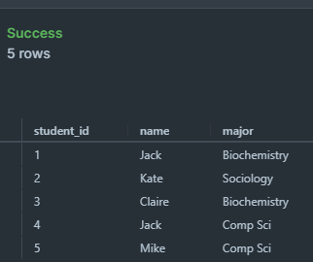
* Notice: jack & Claire changed majors
* UPDATE student
* SET name = ‘Tom’, major = ‘undecided’
* WHERE student_id = 1;
* 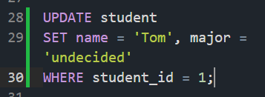
* 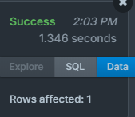
* 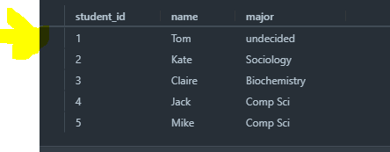
* 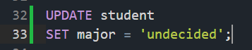
* 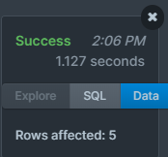
* 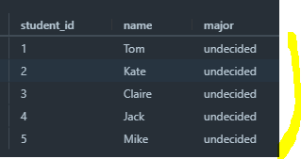
* Deleting a specific row / group of rows
* DELETE FROM student
* WHERE student_id = 5;
* 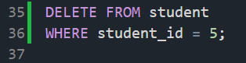
* 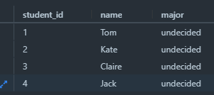
* Notice: Mike no longer in table
* DELETE FROM student
* WHERE name = ‘Tom’ AND major = ‘undecided’
* 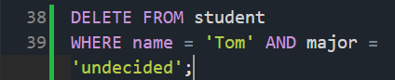
* 
* 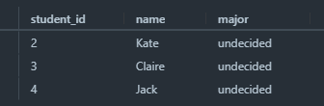
* Notice Tom got deleted from the table
* DELETE FROM student; <- thi deletes EVERYTHING from the table
* 
* 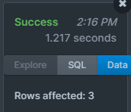
* 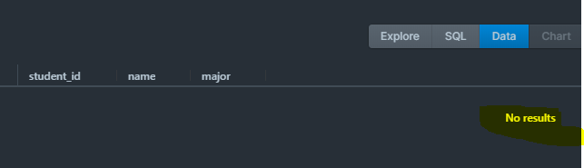

Basic Queries

* Use when need specific info/ entries within the database that meet a specific condition
* Or multiple conditions
* SELECT <- important keyword; notifies RDBMS that we want to get some info from the DB
* SELECT *
* FROM student;
  + Also known as: select every column from the student table
  + 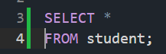
  + 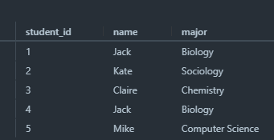
  + SELECT name
  + FROM student;
  + 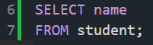
  + 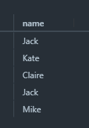
  + SELECT name, major
  + FROM student;
  + 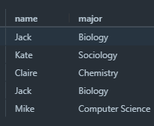
  + Pretty much specifying which columns we want back
  + Another equivalent option/ query to above:
  + SELECT student,name, student.major
  + FROM student
  + 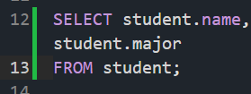
  + 
  + SELECT student.name, student,major
  + FROM student
  + ORDER BY name;
  + 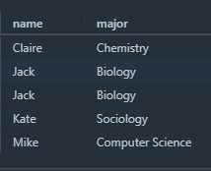
  + Notice: results are ordered by name (alphabetically)
  + By default, it is in ascending order
  + SELECT student.name, student.major
  + FROM student
  + ORDER BY name DESC;
  + 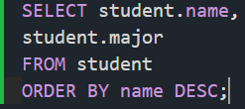
  + 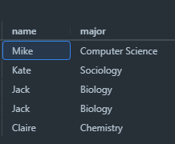
  + Notice: descending order change
  + Could still order by student id even if it is not within the command/ results itself
  + SELECT student.name, student.major
  + FROM student
  + ORDER BY student_id DESC;
  + 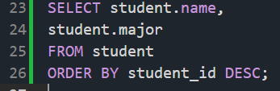
  + 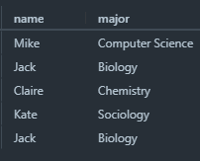
  + To see change clearly, see below:
  + SELECT *
  + FROM student
  + ORDER BY student_id DESC;
  + 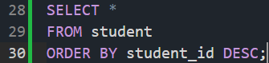
  + 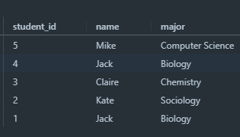
  + 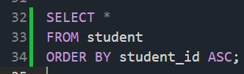
  + 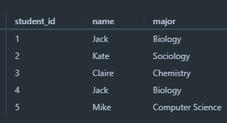
  + Can also order by different subcolumns:
  + SELECT *
  + FROM student
  + ORDER BY major, student_id;
  + Will order by major 1st then student_id
  + 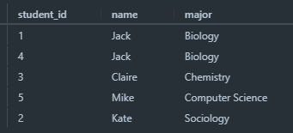
  + 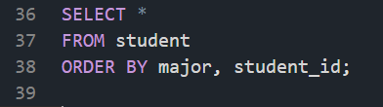
  + SELECT *
  + FROM student
  + ORDER BY major, student_id DESC;
  + 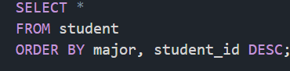
  + Notice: entry w/ student id appeared first
  + 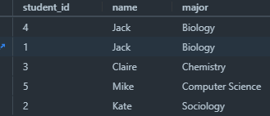<- vs.
  + 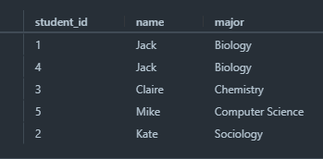
  + Can also limit the amount of results you are getting
  + SELECT *
  + FROM student
  + LIMIT 2;
  + This limits the results I get back; to 2 (instead of getting all the students back)
  + 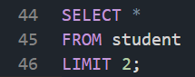
  + 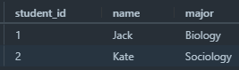
  + SELECT *
  + FROM student
  + ORDER BY student_id DESC
  + LIMIT 2;
  + 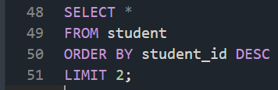
  + 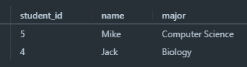
  + Notice: now we get 2 lowest entries in terms of student_id
* Filtering w/ WHERE
* SELECT *
* FROM student
* WHERE major = ‘Biology’;
* 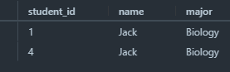
* Provide biology majors
* 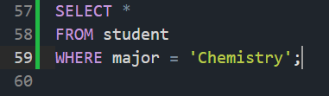
* 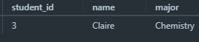
* SELECT name, major
* FROM student
* WHERE major = ‘Chemistry’;
* 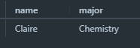
* SELECT name, major
* FROM student
* WHERE major = ‘Chemistry’ OR major = ‘Biology’
* 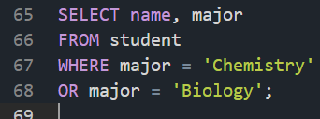
* 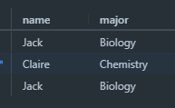
* SELECT name, major
* FROM student
* WHERE major = ‘Chemistry’
* OR name = ‘Kate’;
* 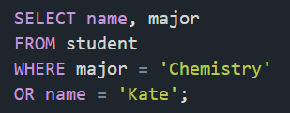
* 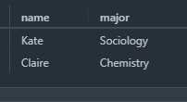
* ‘--’ -> comment
* ‘<’,’>’,’<=’,’>=’,’=’, ‘<>’, ‘AND’, ‘OR’
* ‘<>’ -> means not equal to
* SELECT name, major
* FROM student
* WHERE major <> ‘Chemistry’;
* 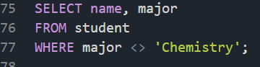
* 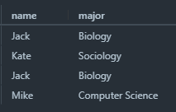
* SELECT name, major
* FROM student
* WHERE student_id < 3;
* 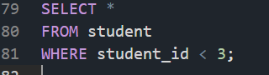
* 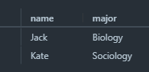
* Can also combine these: WHERE student_id <= 3 AND NAME <> ‘Jack’;
* 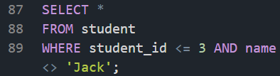
* 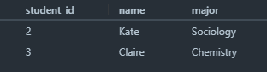
* IN operator
* SELECT *
* FROM student
* WHERE name IN (‘Claire’, ‘Kate’, ‘Mike’);
* 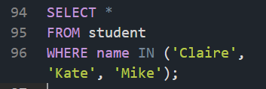
* 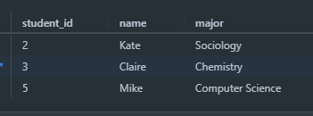
* SELECT *
* FROM student
* WHERE major IN (‘Biology’, ‘Chemistry’);
* 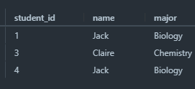
* SELECT *
* FROM student
* WHERE major IN (‘Biology’, ‘Chemistry’) AND student_id > 2;
* 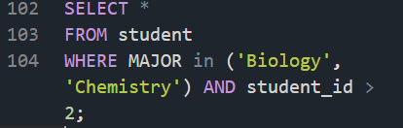
* 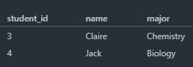

Company Database Into

* Complex database schema
* 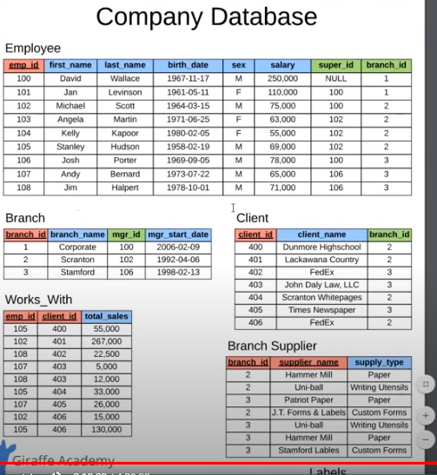

Creating Company Database

* CREATE TABLE employee (
* emp_id INT PRIMARY KEY,
* first_name VARCHAR(40),
* last_name VARCHAR(40),
* birth_day DATE,
* sex VARCHAR(1),
* salary INT,
* super_id INT,
* branch_id INT
* );
* super_id = is the supervisor ID which is a foreign key which points to another employee
* branch_id = is another foreign key which points to the branch table
* NOTE: cannot define super_id and branch_id as foreign keys yet since some tables still have to be created
* BRANCH table:
* CREATE TABLE branch (
* branch_id INT PRIMARY KEY,
* branch_name VARCHAR(40),
* mgr_id INT,
* mgr_start_date DATE,
* FOREIGN KEY(mgr_id) REFERENCES employee(emp_id) ON DELETE SET NULL
* );
* note: the mgr_id is also a foreign key
* References employee column on the Employee table (refer to photo above)
* Whenever we create a foregin key always include ‘ON DELETE SET NULL’
* -- now must set sup_id & branch_id as foreign keys
* Recall, couldn’t do this earlier b/c ‘Branch’ and ‘Employee’ table did not exist
* ALTER TABLE employee
* ADD FOREIGN KEY(branch_id)
* REFERENCES branch(branch_id)
* ON DELETE SET NULL;
* ALTER TABLE employee
* ADD FOREIGN KEY(super_id)
* REFERENCES employee(emp_id)
* ON DELETE SET NULL;

CREATE TABLE client (

client_id INT PRIMARY KEY,

client_name VARCHAR(40),

branch_id INT,

FOREIGN KEY(branch_id) REFERENCES branch(branch_id) ON DELETE SET NULL

);

* branch _id is the foreign key, referencing to branch table

CREATE TABLE works_with (

emp_id INT,

client_id INT,

total_sales INT,

PRIMARY KEY(emp_id, client_id),

FOREIGN KEY(emp_id) REFERENCES employee(emp_id) ON DELETE CASCADE,

FOREIGN KEY(client_id) REFERENCES client(client_id) ON DELETE CASCADE

);

-- create branch supplier table

CREATE TABLE branch_supplier (

branch_id INT,

supplier_name VARCHAR(40),

supply_type VARCHAR(40),

PRIMARY KEY(branch_id, supplier_name),

FOREIGN KEY(branch_id) REFERENCES branch(branch_id) ON DELETE CASCADE

);

* Now all tables for database schema have been created
* Now will be inserting information into these tables
* *-- Corporate*
* INSERT INTO employee VALUES(100, 'David', 'Wallace', '1967-11-17', 'M', 250000, NULL, NULL);
* INSERT INTO branch VALUES(1, 'Corporate', 100, '2006-02-09');
* UPDATE employee
* SET branch_id = 1
* WHERE emp_id = 100;
* INSERT INTO employee VALUES(101, 'Jan', 'Levinson', '1961-05-11',
* Notice: the Employee tables & the branch tables have foreign keys that map to each other
* Notice first line of code, ‘branch_id’ spot should be equal to 1, however, Corporate branch within branch table has not been created yet, thus stated as ‘NULL’
* *-- Scranton*
* INSERT INTO employee VALUES(102, 'Michael', 'Scott', '1964-03-15', 'M', 75000, 100, NULL);
* INSERT INTO branch VALUES(2, 'Scranton', 102, '1992-04-06');
* UPDATE employee
* SET branch_id = 2
* WHERE emp_id = 102;
* INSERT INTO employee VALUES(103, 'Angela', 'Martin', '1971-06-25', 'F', 63000, 102, 2);
* INSERT INTO employee VALUES(104, 'Kelly', 'Kapoor', '1980-02-05', 'F', 55000, 102, 2);
* INSERT INTO employee VALUES(105, 'Stanley', 'Hudson', '1958-02-19', 'M', 69000, 102, 2);
* Again note the circular relation between the foreign keys of the Employee table and the Branch table
* *-- Stamford*
* INSERT INTO employee VALUES(106, 'Josh', 'Porter', '1969-09-05', 'M', 78000, 100, NULL);
* INSERT INTO branch VALUES(3, 'Stamford', 106, '1998-02-13');
* UPDATE employee
* SET branch_id = 3
* WHERE emp_id = 106;
* INSERT INTO employee VALUES(107, 'Andy', 'Bernard', '1973-07-22', 'M', 65000, 106, 3);
* INSERT INTO employee VALUES(108, 'Jim', 'Halpert', '1978-10-01', 'M', 71000, 106, 3);
* Remaining less complex insertions of data
* *-- BRANCH SUPPLIER*
* INSERT INTO branch_supplier VALUES(2, 'Hammer Mill', 'Paper');
* INSERT INTO branch_supplier VALUES(2, 'Uni-ball', 'Writing Utensils');
* INSERT INTO branch_supplier VALUES(3, 'Patriot Paper', 'Paper');
* INSERT INTO branch_supplier VALUES(2, 'J.T. Forms & Labels', 'Custom Forms');
* INSERT INTO branch_supplier VALUES(3, 'Uni-ball', 'Writing Utensils');
* INSERT INTO branch_supplier VALUES(3, 'Hammer Mill', 'Paper');
* INSERT INTO branch_supplier VALUES(3, 'Stamford Lables', 'Custom Forms');
* *-- CLIENT*
* INSERT INTO client VALUES(400, 'Dunmore Highschool', 2);
* INSERT INTO client VALUES(401, 'Lackawana Country', 2);
* INSERT INTO client VALUES(402, 'FedEx', 3);
* INSERT INTO client VALUES(403, 'John Daly Law, LLC', 3);
* INSERT INTO client VALUES(404, 'Scranton Whitepages', 2);
* INSERT INTO client VALUES(405, 'Times Newspaper', 3);
* INSERT INTO client VALUES(406, 'FedEx', 2);
* *-- WORKS_WITH*
* INSERT INTO works_with VALUES(105, 400, 55000);
* INSERT INTO works_with VALUES(102, 401, 267000);
* INSERT INTO works_with VALUES(108, 402, 22500);
* INSERT INTO works_with VALUES(107, 403, 5000);
* INSERT INTO works_with VALUES(108, 403, 12000);
* INSERT INTO works_with VALUES(105, 404, 33000);
* INSERT INTO works_with VALUES(107, 405, 26000);
* INSERT INTO works_with VALUES(102, 406, 15000);
* INSERT INTO works_with VALUES(105, 406, 130000);
* Recall to use chart above as reference
* Now our database is populated with all the information

More Basic Queries

-- Find all employees

SELECT *

FROM employee;

-- Find all clients

SELECT *

FROM client;

-- Find all employees ordered by salary

SELECT *

FROM employee

ORDER BY salary;

SELECT *

FROM employee

ORDER BY salary DESC;

-- Find all employees ordered by sex then name

SELECT *

FROM employee

ORDER BY sex, first_name, last_name;

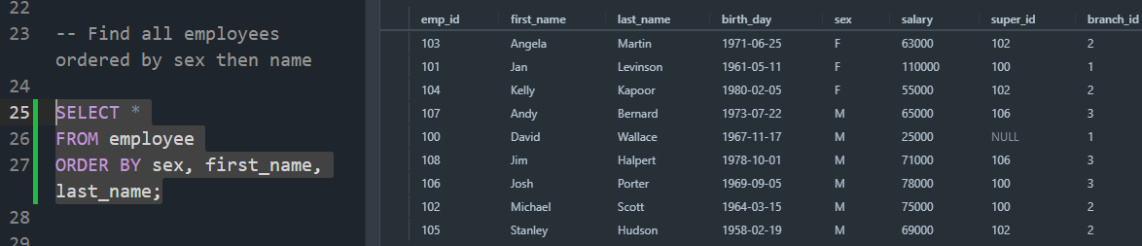

* If there were any duplicates with the first name then it would be the last name referred to for the order

- - Find the first 5 employees in the table

Select *

FROM employee

LIMIT 5;

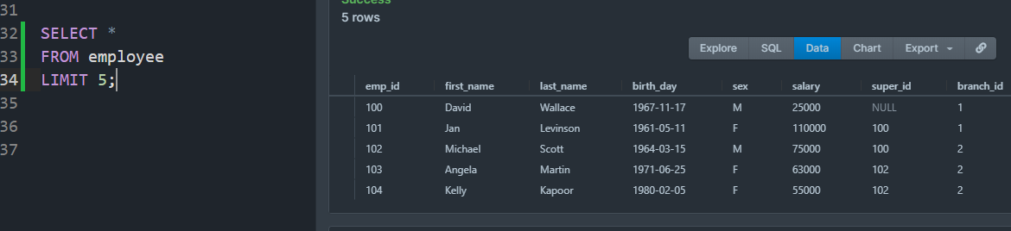

-- Find the first and last names of all employees

SELECT employee.first_name, employee.last_name

FROM employee;

OR

SELECT first_name, last_name

FROM employee;

-- Find the forename and surnames of all employees

SELECT first_name AS forename, last_name AS surname

FROM employee;

* NOTICE: the change in col names as a result

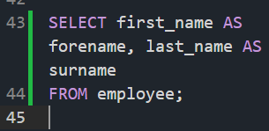

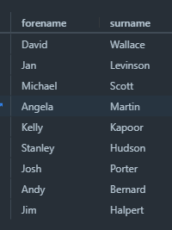

* NEW SQL keyword in this lecture: DISTINCT
* -- find out all the different genders
* SELECT DISTINCT sex
* FROM employee;

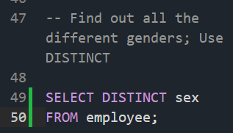

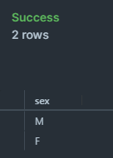

-- Distinct branch ids that employees have

SELECT DISTINCT branch_id

FROM employee;

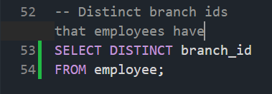

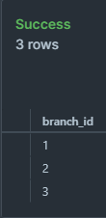

* Generally, will use DISTINCT to find out different data within a column

Functions

-- Find the number of employees

SELECT COUNT(emp_id)

FROM employee;

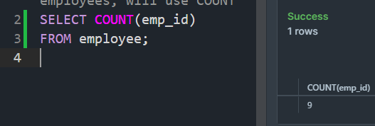

* SQL is stating to Select how many employee ids are in the employee table
* (9 employees inside the table)

-- Count how many employees have supervisors

SELECT COUNT(super_id)

FROM employee;

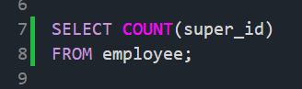

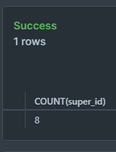

* Get 8 instead of 9 due to the ‘NULL’ value in 1 row

-- Find the number of female employees born after 1970; USE WHERE

SELECT COUNT(emp_id)

FROM employee

WHERE sex = ‘F’ AND birth_date > ‘1970-01-01’;

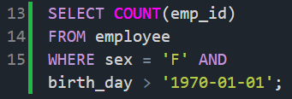

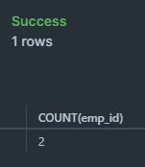

-- Find the average of all employee’s salaries; USE AVG

SELECT AVG(salary)

FROM employee;

-- we can filter this further

SELECT AVG(salary)

FROM employee

WHERE sex = ‘M’;

-- Find the sum of all employee’s salaries

SELECT SUM(salary)

FROM employee;

Aggregation - where we can use these functions and display the data we get back in a more helpful way; GROUP BY

-- Find out how many males and females there are

SELECT COUNT(sex), sex

FROM employee

GROUP BY sex;

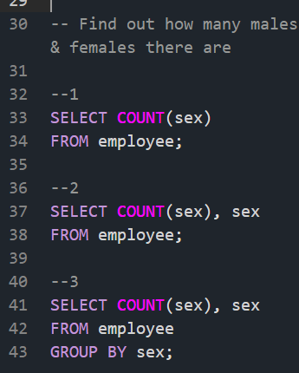

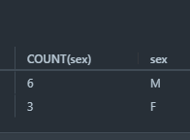

-- Find the total sales of each salesman

SELECT SUM(total_sales), emp_id <- comma, the column we want

FROM works_with

GROUP BY emp_id;

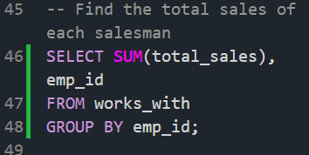

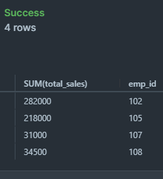

-- similar case w/ client; how much does each client spend?

SELECT SUM(total_sales), client_id

FROM works_with

GROUP BY client_id;

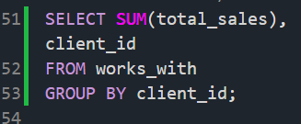

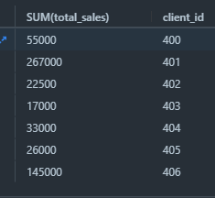

* “Add up total sales of each client, then group them”

Wildcards - defines patterns that we want to match w/ specific data; IOW want to grab data that matches a specific pattern

% _

-- % = any # of characters, _ = one character

-- Find any client's who are an LLC

-> LLC = Limited Liability Company; refer to above pdf/ database chart thing

SELECT *

FROM client

WHERE client_name LIKE ‘%LLC’; <- pattern defines

“Return any # of characters w/ LLC in it”

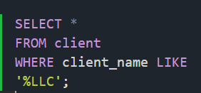

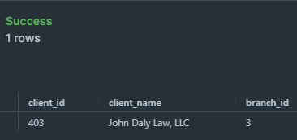

-- Find any branch suppliers who are in the label business

SELECT *

FROM branch_supplier

WHERE supplier_name LIKE ‘%Labels’;

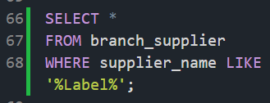

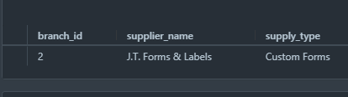

-- Find any employee born in october

SELECT *

FROM employee

WHERE birth_date LIKE ‘%-10-%’;

-- Answer provided:

SELECT *

FROM employee

WHERE birth_date LIKE ‘____-10%’;

-- Find any clients who are schools

SELECT *

FROM client

WHERE client_name LIKE ‘%school%’;

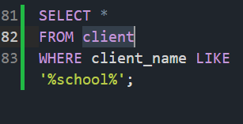

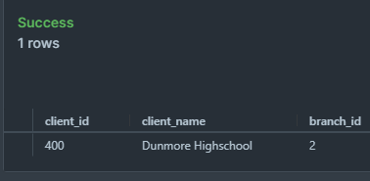

Union - operator in SQL used to combine multiple SELECT statements into 1

-- Find a list of employee & branch names

1.

Select first_name

FROM employee;

SELECT branch_name

FROM branch;

2. How it should be done to combine both SELECT statements

SELECT first_name

FROM employee

UNION

SELECT branch_name

FROM branch;

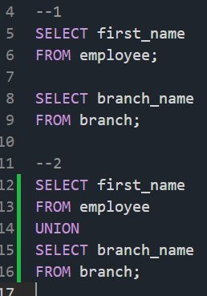

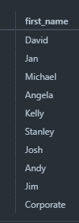

* Rule: have to have the SAME number of cols in each SELECT statement
  + Ex. will get an error if you run the following (since first statement has 2 cols and 2nd has only one)
  + SELECT first_name, last_name
  + FROM employee
  + UNION
  + SELECT branch_name
  + FROM branch;
  + -> ERROR
* Rule: must have similar data type
  + Ex. first_name and branch_name are both strings
* Another example:
  + SELECT first_name
  + FROM employee
  + UNION
  + SELECT branch_name
  + FROM branch
  + UNION
  + SELECT client_name
  + FROM client;
  + 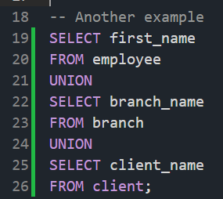
  + 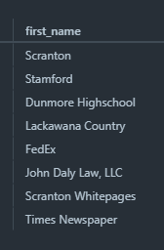
  + Notice: the column name is ‘first_name’ within the results
    - Reason: w/in the first SELECT statement, the column we were grabbing from was ‘first_name’
    - However, can change this with AS
    - SELECT first_name AS Company_Names
    - FROM employee
    - UNION
    - SELECT branch_name
    - FROM branch
    - UNION
    - SELECT client_name
    - FROM client;
    - 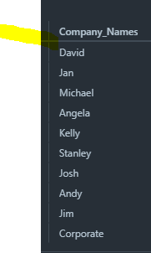
* -- find a list of all clients & branch suppliers’ names
* SELECT client_name
* FROM client
* UNION
* SELECT supplier_name
* FROM branch_supplier;
* 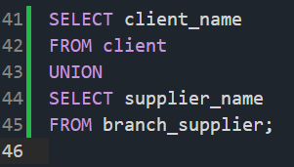
* 
* SELECT client_name, branch_id
* FROM client
* UNION
* SELECT supplier_name, branch_id
* FROM branch_supplier
* 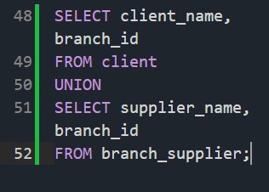
* 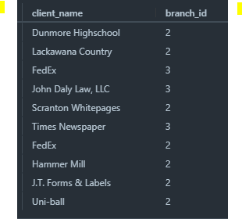
* To avoid confusion, can use the following
* SELECT client_name, client.branch_id
* FROM client
* UNION
* SELECT supplier_name, branch_supplier.branch_id
* FROM branch_supplier;

-- Find a list of all money spent or earned by the company

SELECT salary

FROM employee

UNION

SELECT total_sales

FROM works_with;

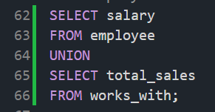

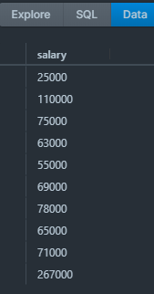

* Note the rules: must have same number of columns within SELECT statements
* AND similar data types

Joins

* Used to combine rows from two or more tables based on a related column between them
* Combine from different tables into a single result, which we can then use to find out about specific info w/in DB
* INSERT INTO branch VALUES(4, ‘Buffalo’, NULL, NULL)
* 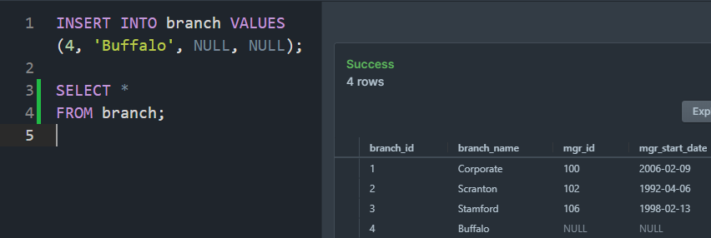
* -- Find all branches and the names of their managers
* SELECT employee.emp_id, employee.first_name, branch.branch_name
* FROM employee
* JOIN employee.emp_id = branch.mgr_id;

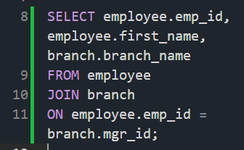

* Notice headers are w/in 1st SELECT statement

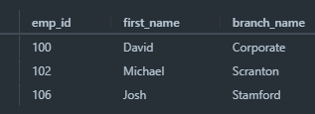

* There are 4 basic types of joins
* 1. - general join above (inner join)
  + Inner join: combines rows of multiple tables whenever there is a shared column
* 2. LEFT JOIN
* SELECT employee.emp_id, employee.first_name, branch.branch_name
* FROM employee
* LEFT JOIN branch
* ON employee.emp_id = branch.mgr_id

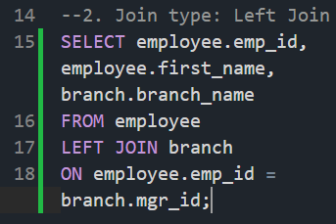

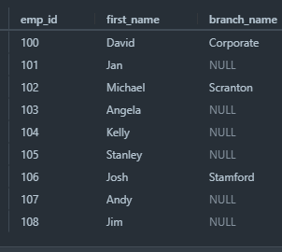

* Notice: Now, all of the employees got included in the results
* So when we used Inner JOIN only employees who were branch managers got included
* But for LEFT JOIN, all employees within employee table appeared within the results
* 3. RIGHT JOIN: all branches within branch table will appear
* SELECT employee.emp_id, employee.first_name, branch.branch_name
* FROM employee
* RIGHT JOIN branch
* ON employee.emp_id = branch.mgr_id;

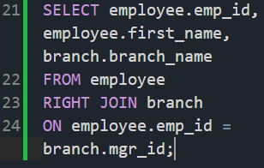

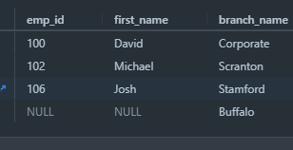

* Left join: get all the rows from the left table (including rows with NULL values)
* Right join: get all the rows from the right table (including rows with NULL values)
* 4. Full outer JOIN <- can’t be used in MySQL
  + Full outer join is basically a left join and a right join combined

Nested Queries

* Use multiple SELECT statements to retrieve specific info
* Will use results of one SELECT statement to influence results of another SELECT statement
* -- Find names of all employees who have sold over 40,000 to a single client
  + We have part of the data in the Employee table and part of the data in the Works_With table; so we’ll use a nested query
  + Step 1: get all info from works_with; get employee ids of those who sold more than 30k worth of product
  + SELECT works_with.emp_id
  + FROM works_with
  + WHERE works_with.total_sales > 30000;
  + 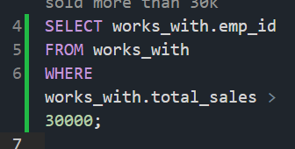
  + 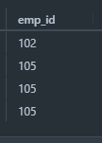
  + Step2: Want those employee first names and last names
  + SELECT employee.first_name, employee.last_name
  + FROM employee
  + WHERE <- This is where we put the nested query
  + employee.emp_id IN ((will put SELECT statement above)
    - SELECT works_with.emp_id
    - FROM works_with
    - WHERE
    - Works_with.total_sales > 30000
    - );
  + 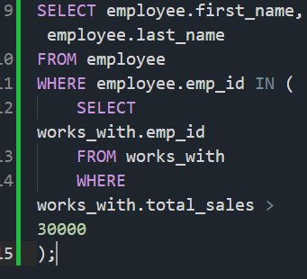
  + 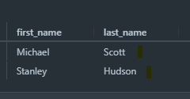
  + -- Find all clients who are handled by the branch that Michael Scott manages
  + -- Assume you know Michael’s ID
  + Step1:
  + SELECT works_with.client_id
  + FROM works_with
  + WHERE works_with.emp_id = 102;
  + 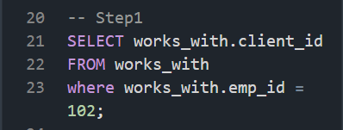
  + 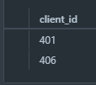
  + Step2: (Overall)
  + SELECT client.client_name
  + FROM client
  + WHERE client_id IN (
  + SELECT works_with.client_id
  + FROM works_with
  + WHERE works_with.emp_id = 102
  + );
  + 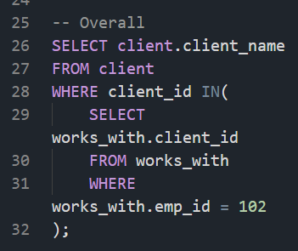
  + 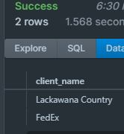
  + Note: always grab data from one table that can be used as a connection to grab data from another table
  + When SQL sees a nested query it starts inner then outer

CORRECT:

SELECT client.client_name

FROM client

WHERE client.branch_id = (

SELECT branch.branch_id

FROM branch

WHERE branch.mgr_id = 102

);

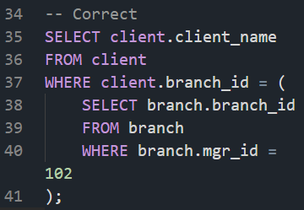

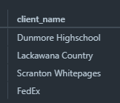

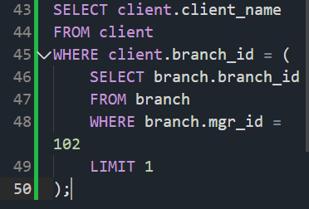

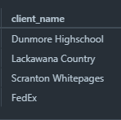

SELECT client.client_name

FROM client

WHERE client.branch_id = (

SELECT branch.branch_id

FROM branch

WHERE branch.mgr_id = 102

LIMIT 1 -> makes sure we only have 1

);

On Delete

* Deleting entries in the database when they have foreign keys associated to them
* CREATE TABLE branch(
  + branch _id INT PRIMARY KEY,
  + Branch_name VARCHAR(40),
  + mgr_id INT,
  + mgr_start_date DATE,
* FOREIGN KEY(mgr_id) REFERENCES employee(emp_id) ON DELETE SET NULL
* );
* ON DELETE SET NULL -> deletes something from DB and provides a NULL value
* ON DELETE CASCADE -> just deletes the entire row
* 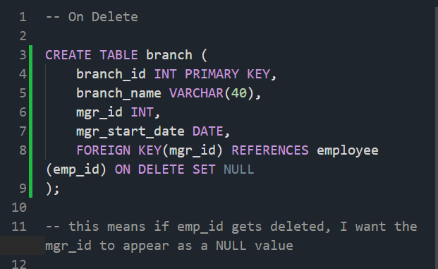
* Try deleting Michael Scott
* DELETE FROM employee
* WHERE emp_id = 102;

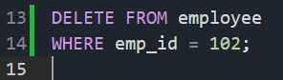

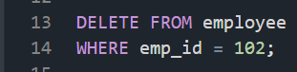

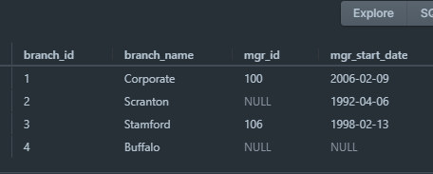

* So the mgr_id which was set as a foreign key is now set to NULL
* 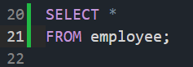
* 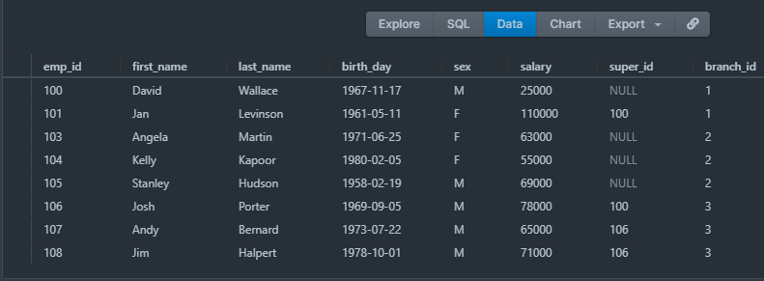
* Notice: alot of the super_ids are NULL

-- ON DELETE CASCADE

- CREATE TABLE branch_supplier(

branch_id INT,

supplier_name VARCHAR(40),

supply_type VARCHAR(40),

PRIMARY KEY(branch_id, supplier_name),

FOREIGN KEY(branch_id) REFERENCES branch(branch_id) ON DELETE CASCADE

);

* If the branch_id of which stored the foreign key gets deleted, then we are just going to delete the entire row in the database
* DELETE FROM branch
* WHERE branch_id = 2;
* 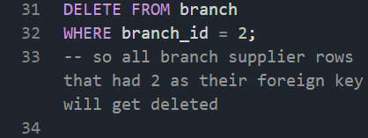
* 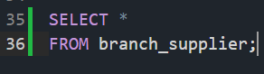
* 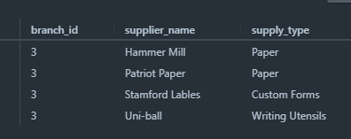
* Notice: no more suppliers that supply branch 2
* Instead of NULL it just deletes them entirely
* Why use ON DELETE CASCADE instead of ON DELETE NULL?
* Used ON DELETE SET NULL for mgr_id since it’s a foreign key not a primary key; so manager id is not really essential for branch table
* However, in Branch supplier table, the branch_id is part of the primary key and NOTE: a primary key cannot have a NULL value; so we’d just have to delete the entire thing
* NOTE: when involving a column part of the primary key ALWAYS use ON DELETE CASCADE

Triggers

* Trigger: a block of SQL code which we could write which will define a certain action that should happen when a certain operation is performed on the DB
* Ex. Tell SQL to do something when particular data has been added to the table, deleted from a DB table
* Triggers will be written in command line
* Use firstDB
* 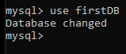
* Configuring mySQL to insert a value into the trigger_test value whenever a value gets inserted into the employee table; pretty much automating
* DELIMITER -> changes MySQL’s delimiter (;)
* DELIMITER $$
* CREATE
  + TRIGGER my_trigger BEFORE INSERT
  + ON employee
  + FOR EACH ROW BEGIN
    - INSERT INTO trigger_test VALUES(‘added new employee’);

- END$$

DELIMITER ; -> changes delimete back to ‘;’

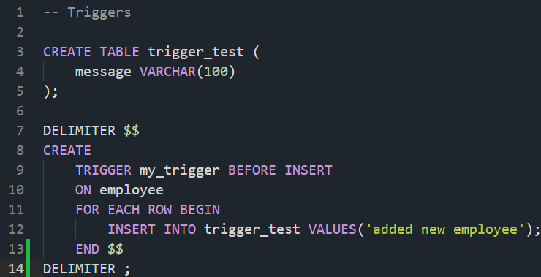

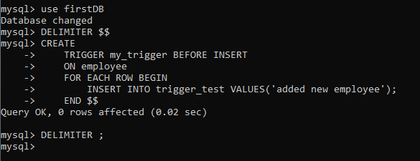

-- will add another employee

INSERT INTO employee

VALUES(109, ‘Oscar’, ‘Martinez’, ‘1968-02-19’, ‘M’, 69000, 106, 3);

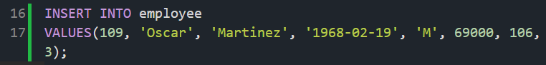

* SELECT *
* FROM trigger_test;
* 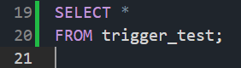
* 
* So it worked! The trigger got set up correctly.
* Again will insert something into the employee table
* ‘New.first_name’; ‘New’ will refer to the row that is getting inserted
* ‘first_name’ -> then I can access specific columns to the row
* So ‘New.first_name’ will give me the first name of the employee being inserted
* So, we’ll insert another employee

INSERT INTO employee

VALUES(110, ‘Kevin’, ‘Malone’, ‘1978-02-19’, ‘M’, 69000, 106, 3);

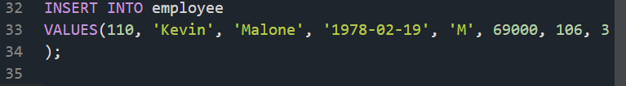

DELIMITER $$

CREATE

TRIGGER my_trigger1 BEFORE INSERT

ON employee

FOR EACH ROW BEGIN

INSERT INTO trigger_test VALUES(NEW.first_name);

END$$

DELIMITER ; (This should be before the Kevin Malone employee INSERT)

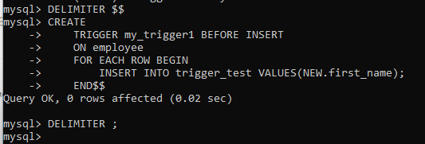

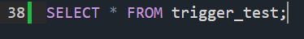



* Something with conditionals (if, elif, else)
* 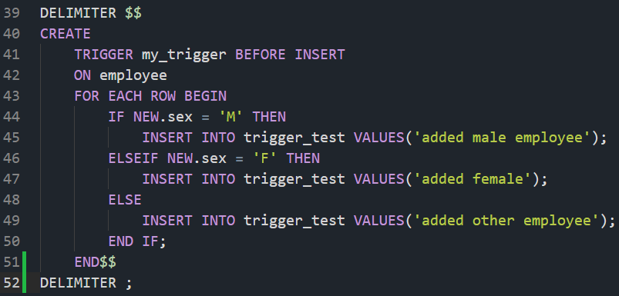
* *** my_trigger2
* 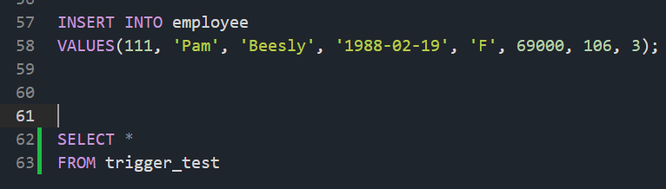
* 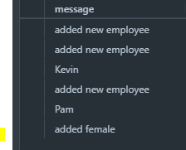
* Can also create triggers for INSERT, UPDATE, DELETE
* Usually use AFTER DELETE opposed to BEFORE DELETE
* Can also drop trigger
* DROP TRIGGER my_trigger;

ER Diagrams Intro

ER = Entity Relationship

* Entity: An object we want to model and store information about
* Want to design a database? -> NEED a database schema i.e. tables, attributes of those tables etc.
  + ER diagram helps with such design/ schema
* 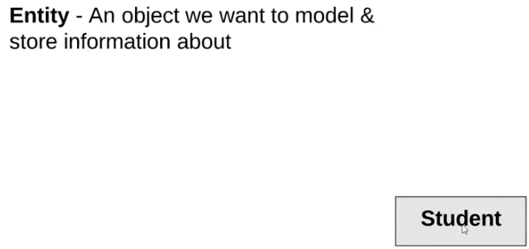
* Attributes: specific pieces of information about an entity

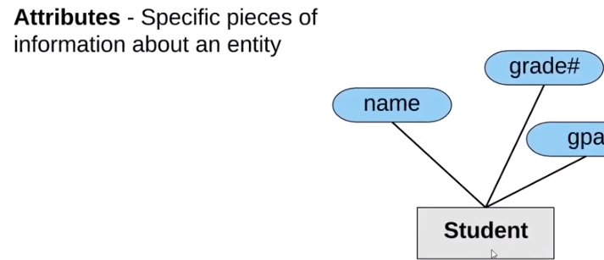

* Primary Key: An attribute(s) that uniquely identifies an entry in the database table
* 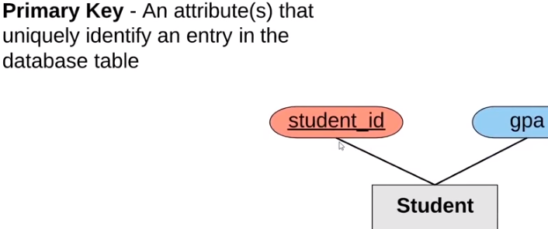
* Note: Primary keys are underlined
* Composite Attribute: an attribute that can be broken up into sub-attributes

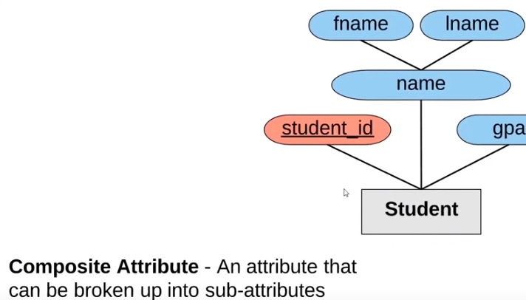

* Multi-valued attribute: an attribute that can have more than one value
* 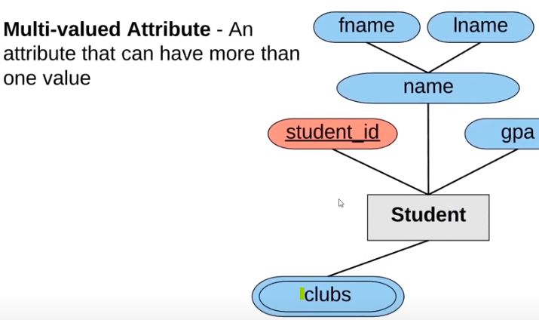
* Derived attribute: an attribute that can be derived from other attributes
* 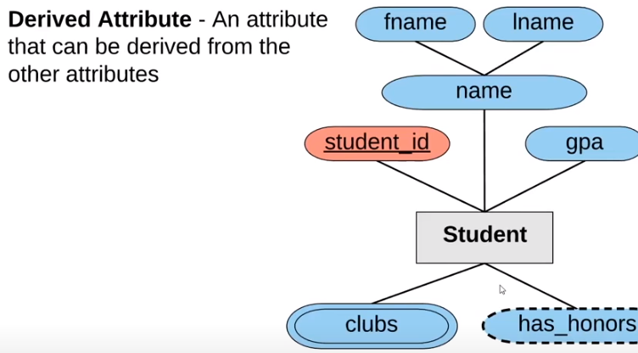
* Ex: ‘has_honors’ can be derived from ‘gpa’
* Multiple Entities: You can define more than one entity in the diagram
* 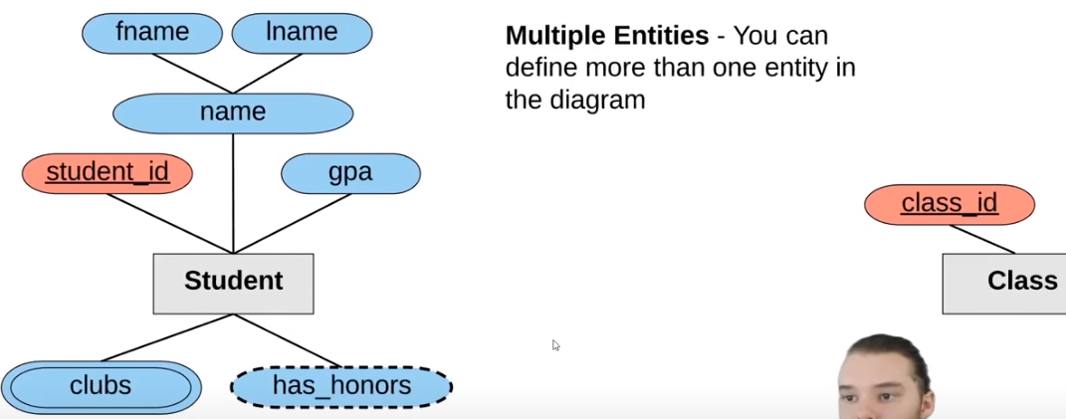
* Relationships: defines a relationship between 2 entities
* Total Participation: All members must participate in the relationship
* 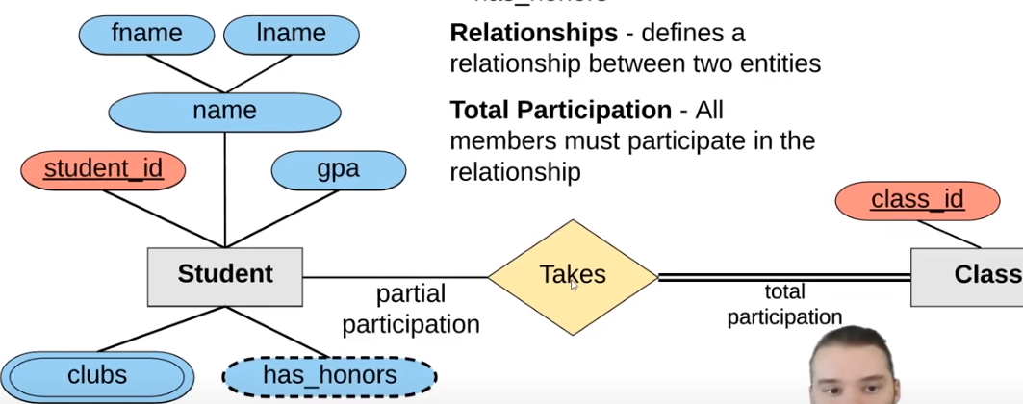
* 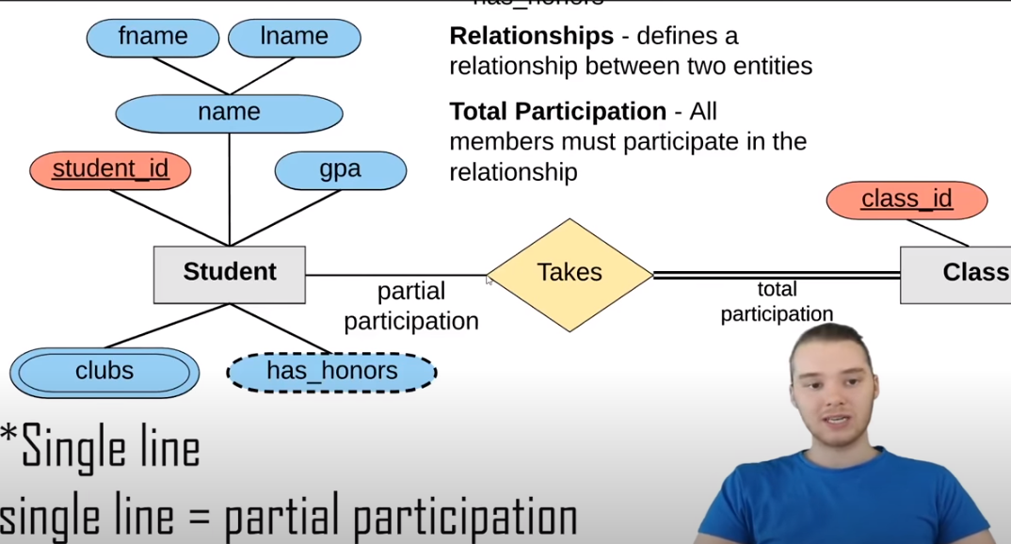
* - i.e. not all students have to be taking a class
* - total participation means all students need to be in a class (FULL participation)
* Takes is the relationship
* 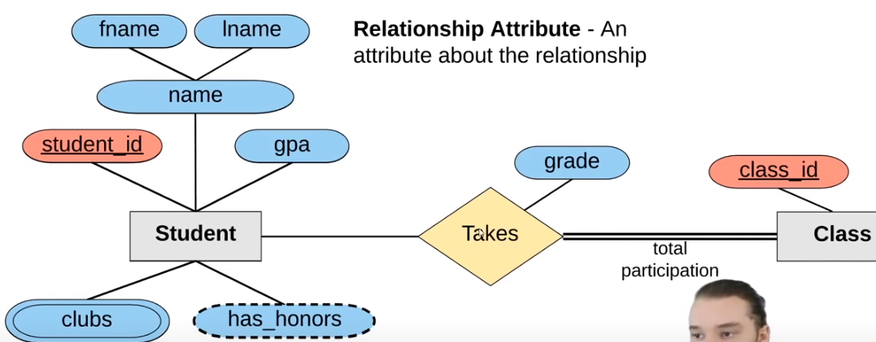
* 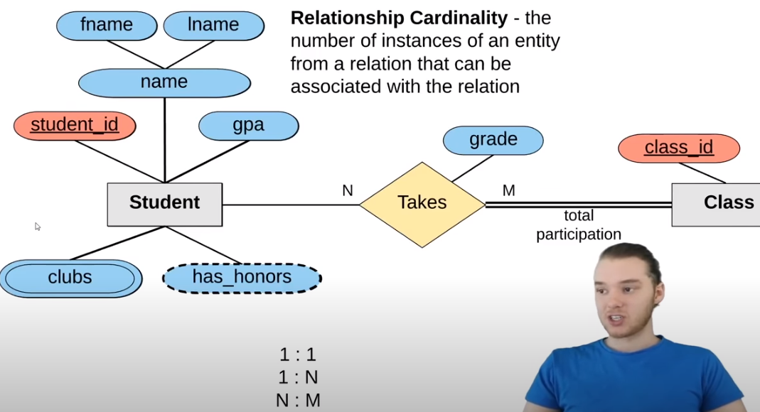
* 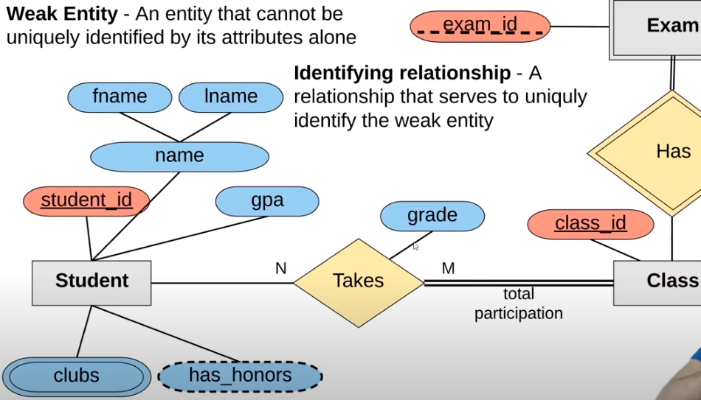

Designing and ER Diagram

3:57